
Picture 1. Global Pipeline Workflow

Enable API
gcloud projects list # to get project ID
export PROJECT_ID="your-project-id" # Set your project id in here

gcloud services enable iamcredentials.googleapis.com \
run.googleapis.com \
artifactregistry.googleapis.com --project="${PROJECT_ID}"

Create a new service account in Google Cloud IAM
The first thing we must do is create Service Account in Google Cloud IAM, Service Account functions as a restriction on access to resources we use later. We can use this command:

gcloud iam service-accounts create "cloud-run-sa" --project="${PROJECT_ID}" --description="Cloud Run Service Account" --display-name="Cloud Run Service Account"

We set roles as Artifact Registry Admin and Cloud Run Admin because we need access to those resources, we can run this command:

gcloud projects add-iam-policy-binding "${PROJECT_ID}" --member="serviceAccount:cloud-run-sa@${PROJECT_ID}.iam.gserviceaccount.com" --role="roles/artifactregistry.repoAdmin"

gcloud projects add-iam-policy-binding "${PROJECT_ID}" --member="serviceAccount:cloud-run-sa@${PROJECT_ID}.iam.gserviceaccount.com" --role="roles/run.admin"

gcloud projects add-iam-policy-binding "${PROJECT_ID}" --member="serviceAccount:cloud-run-sa@${PROJECT_ID}.iam.gserviceaccount.com" --role="roles/iam.serviceAccountUser"

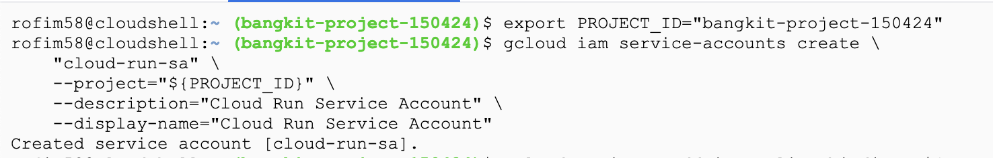
Picture 2. Run the command to create the service account

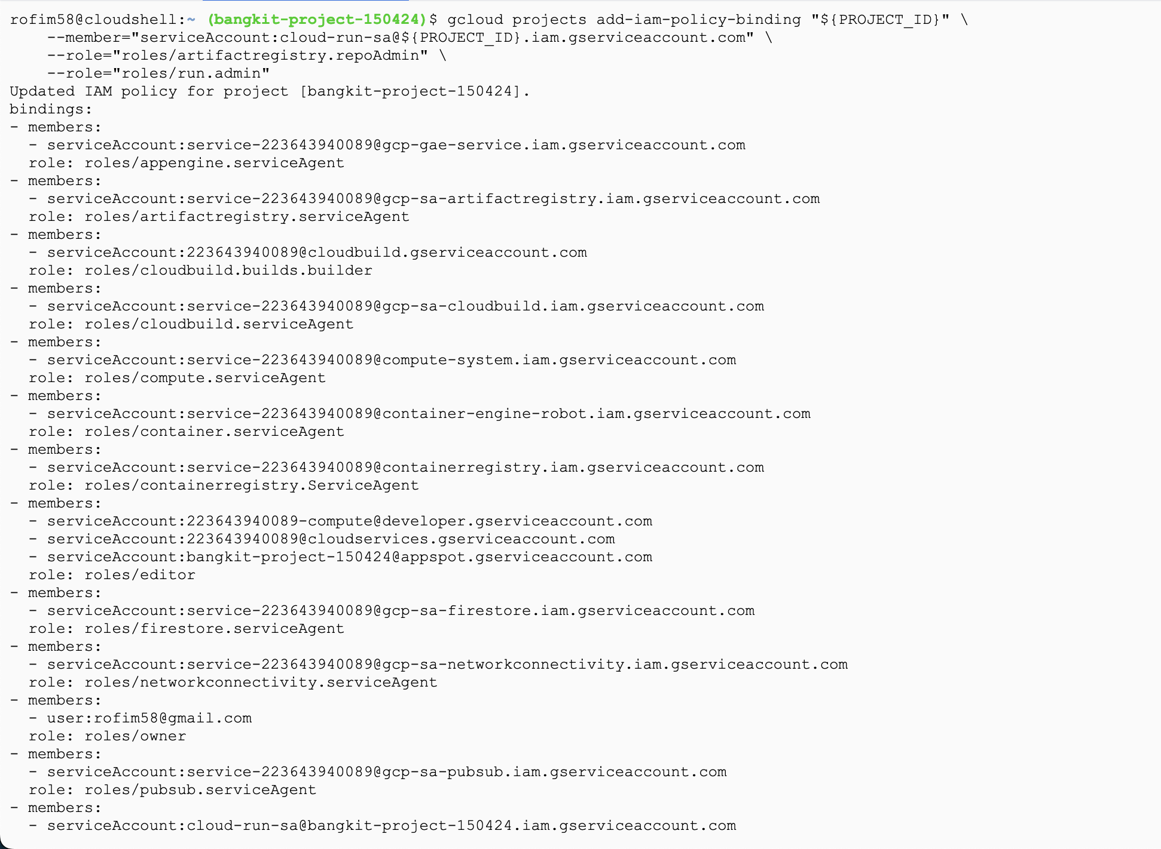
Picture 3. Run the command to assign a role to the service account

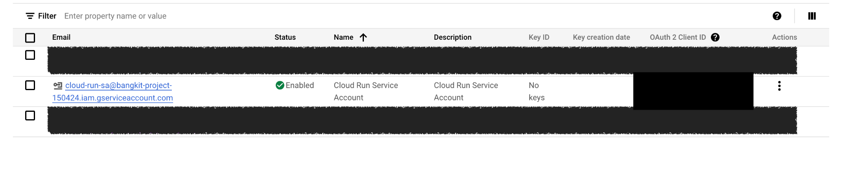
Picture 4. Result service account

Create a new Workload Identity Pool
A workload identity pool is an entity that lets you manage external identities.

First, we must export the repo owner and repo name
export REPO_OWNER="your-github-username"
export REPO_NAME="your-repo-name"

We create a Workload Identity Pool we named “github” using this command:

gcloud iam workload-identity-pools create "github" \
--project="${PROJECT_ID}" \
--location="global" \
--display-name="GitHub Actions Pool"

We can check WIP was successfully created or not using this command:

gcloud iam workload-identity-pools describe "github" \
--project="${PROJECT_ID}" \
--location="global" \
--format="value(name)"

We create OpenID Connect for an identity provider, This command sets up an OIDC identity provider that allows Google Cloud to trust tokens issued by GitHub Actions. By mapping specific attributes from the GitHub OIDC token, it enables fine-grained access control based on these attributes in your Google Cloud environment:

gcloud iam workload-identity-pools providers create-oidc "github-repo-provider" \
--project="${PROJECT_ID}" \
--location="global" \
--workload-identity-pool="github" \
--display-name="My GitHub repo Provider" \
--attribute-mapping="google.subject=assertion.sub,attribute.actor=assertion.actor,attribute.repository=assertion.repository,attribute.repository_owner=assertion.repository_owner,attribute.repository_id=assertion.repository_id" \
--issuer-uri="https://token.actions.githubusercontent.com"

This sequence of commands allows a specific GitHub repository to assume the cloud-run-sa service account's identity, enabling it to interact with Google Cloud resources as this service account. This setup is useful for securely granting permissions to GitHub Actions workflows to interact with Google Cloud.

export SA_EMAIL="cloud-run-sa@${PROJECT_ID}.iam.gserviceaccount.com"

export WORKLOAD_POOL=`gcloud iam workload-identity-pools describe "github" \
--project="${PROJECT_ID}" \
--location="global" \
--format="value(name)"`

gcloud iam service-accounts add-iam-policy-binding ${SA_EMAIL} --project="${PROJECT_ID}" --role="roles/iam.workloadIdentityUser" --member="principalSet://iam.googleapis.com/${WORKLOAD_POOL}/attribute.repository/${REPO_OWNER}/${REPO_NAME}"

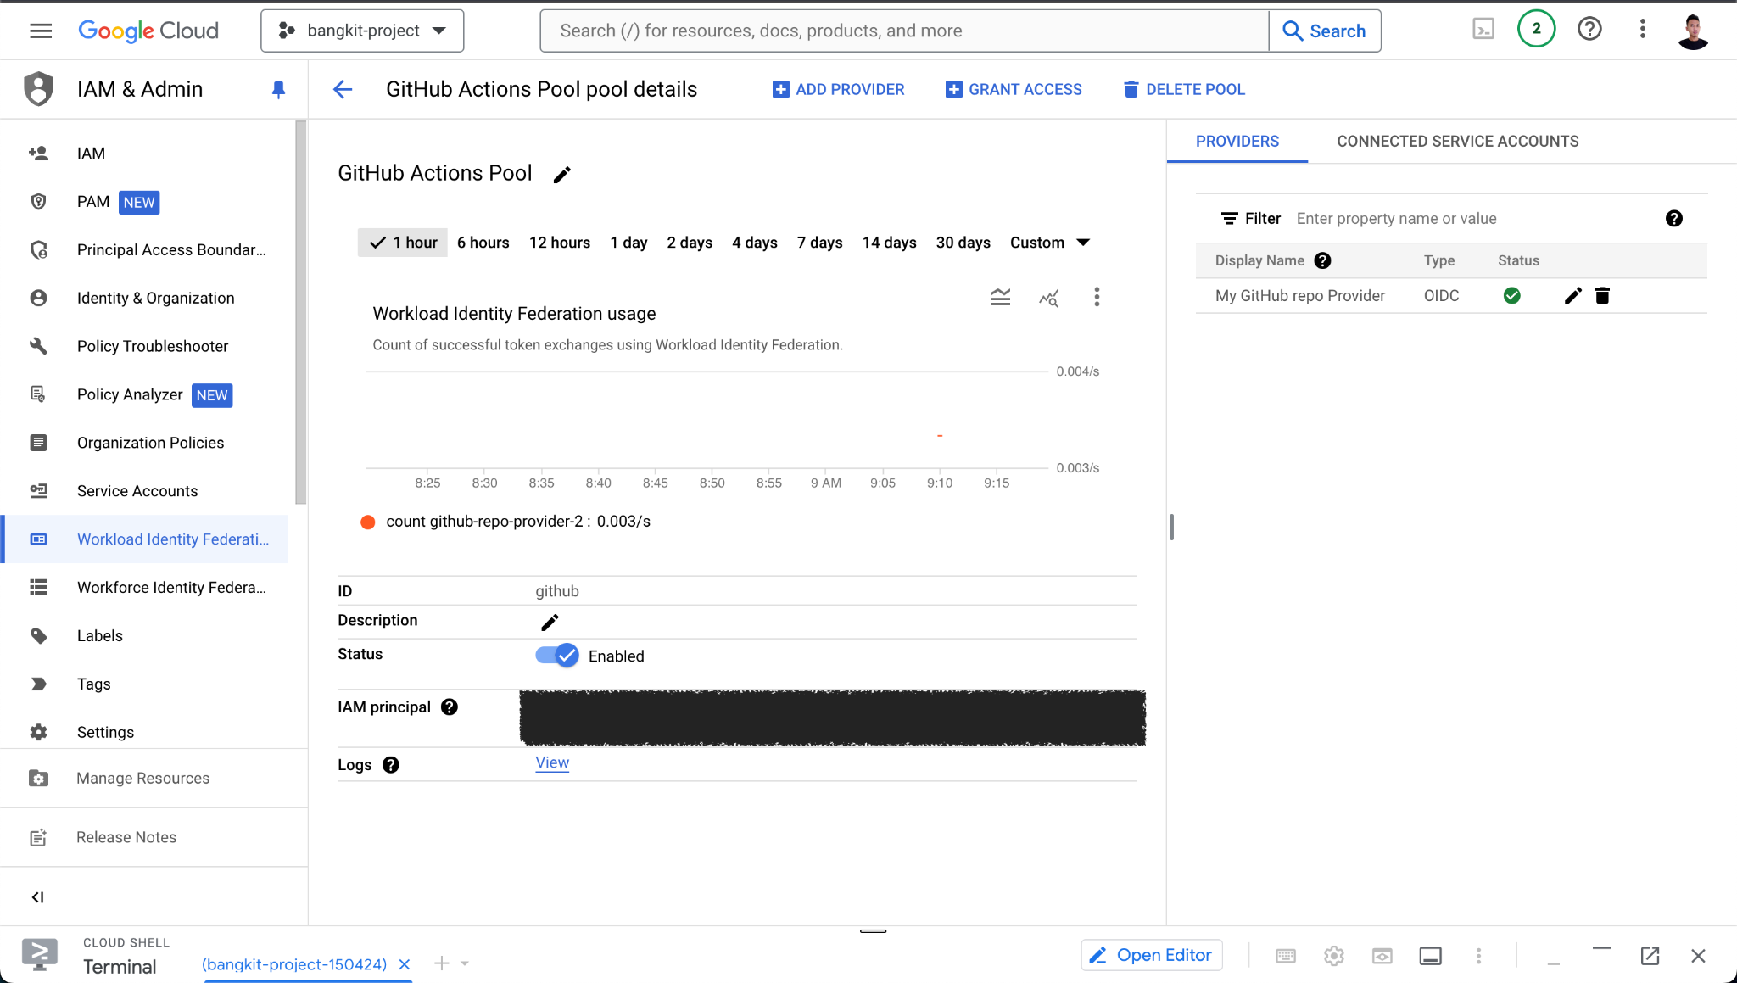
Picture 4. Result in Workload Identity Pool and Provider

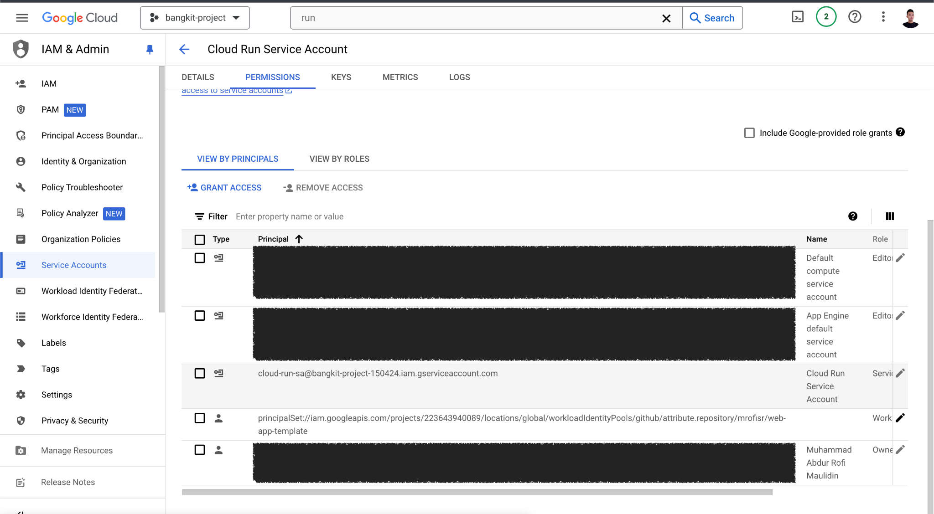
Picture 5. Result in service account assign member and roles

Setup GitHub Actions Secret
To setup GitHub Actions Secret we need 3 items:

- PROJECT_ID
value check with echo $PROJECT_ID

- SERVICE_ACCOUNT
value check with echo $SA_EMAIL

- WORKLOAD_IDENTITY_PROVIDER
value check with command
gcloud iam workload-identity-pools providers describe "github-repo-provider" --project="${PROJECT_ID}" --location="global" --workload-identity-pool="github" --format="value(name)"
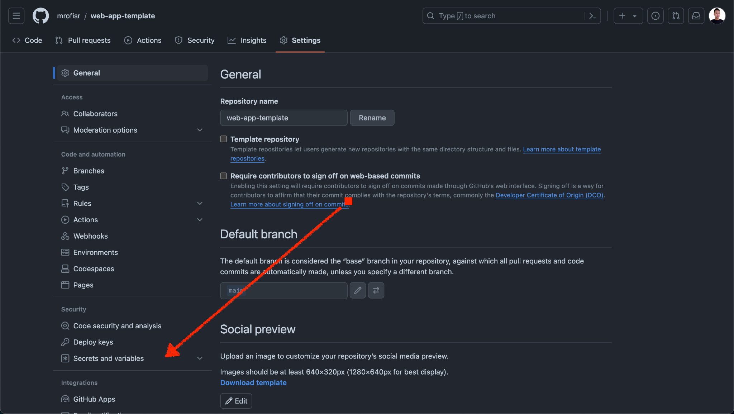
Picture 6. Create GitHub Actions secret

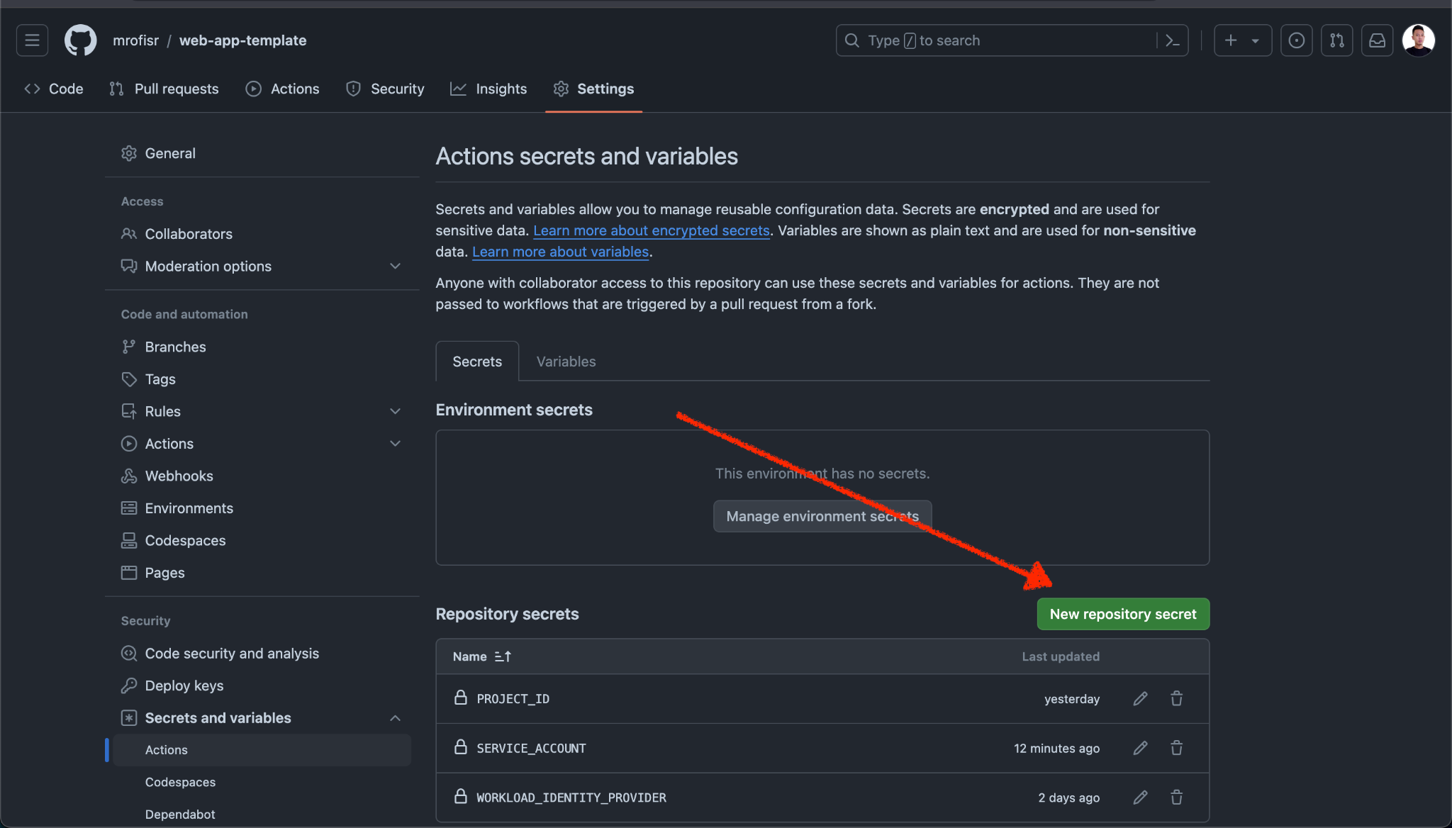
Picture 7. Add new GitHub Actions secret

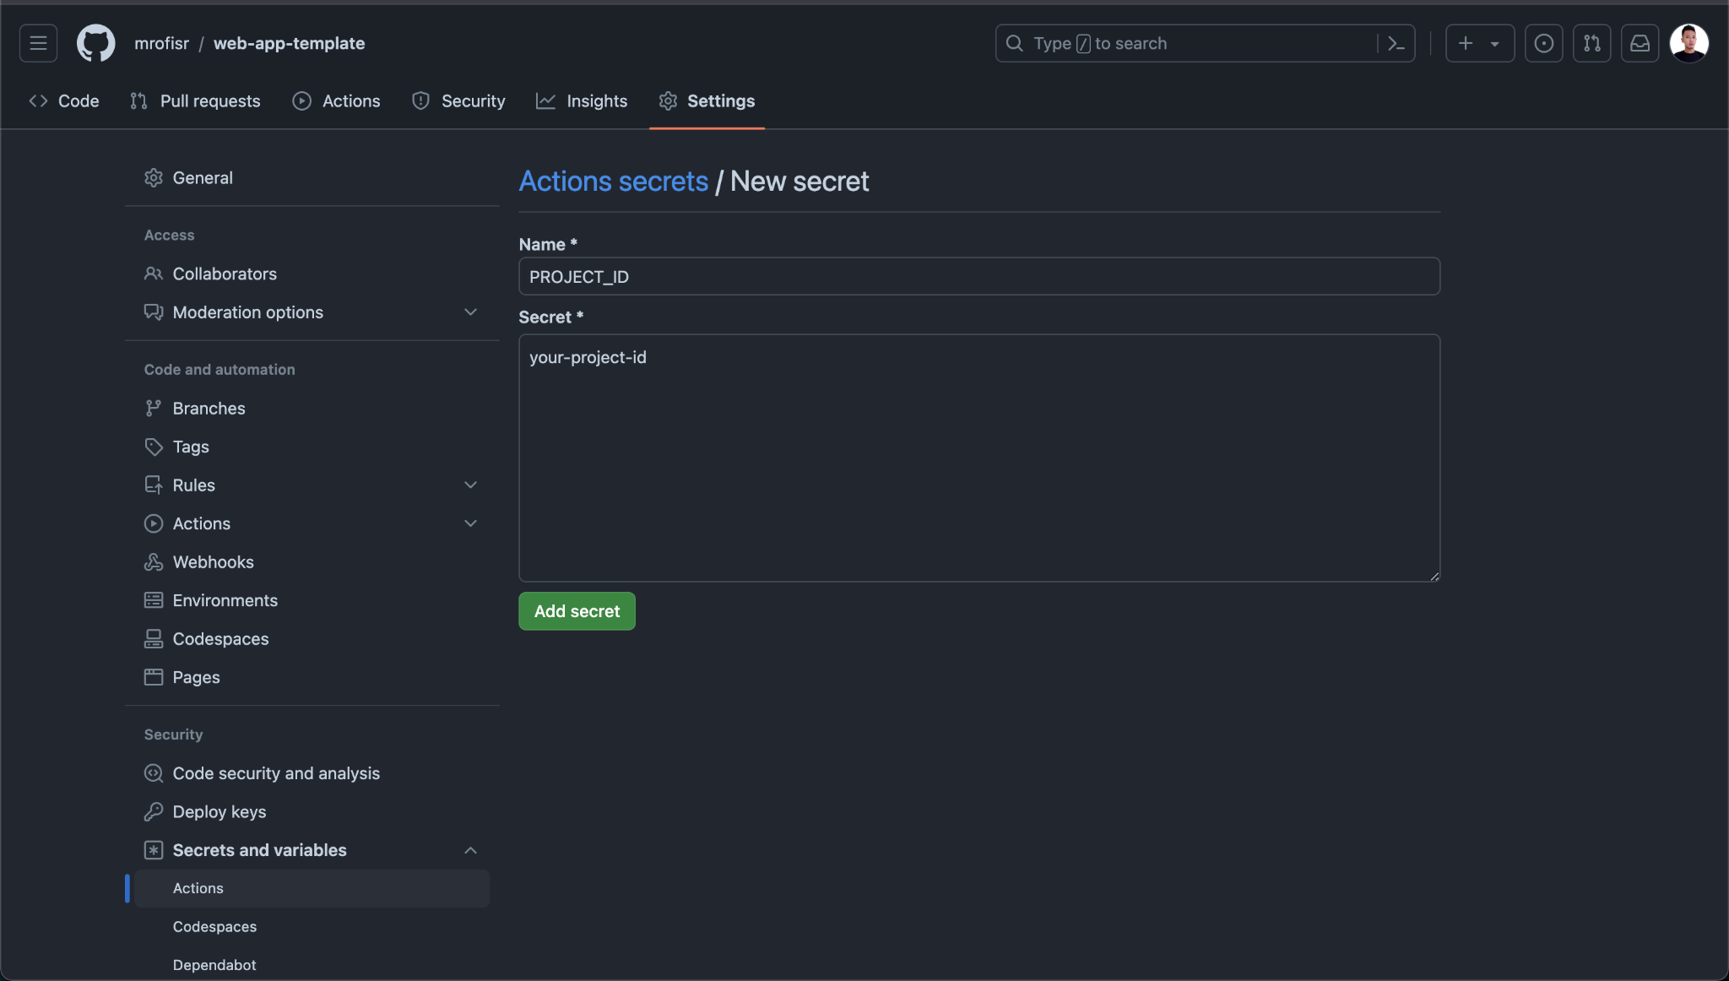
Picture 8. Set key value GitHub Actions secret

Setup Pipeline
First, we must create a directory .github/workflows and create new file inside the directory named deployment.yaml and fill it with this:
name: CI and CD Pipeline to Cloud Run

on:
push:
branches:
- main
- dev
pull_request:
branches:
- main
- dev
types:
- closed

jobs:
build-and-deploy:
permissions:
contents: 'read'
id-token: 'write'
runs-on: ubuntu-latest
steps:
# Step to checkout the code from the repository
- name: Checkout code
id: checkout
uses: actions/checkout@v4

# Step to set environment variables
- name: Set environment variables
id: set-env
run: |
echo "IMAGE_VERSION=${{ github.ref_name }}" >> $GITHUB_ENV

# Step to authenticate with Google Cloud
- name: Gcloud Auth
id: gcloud-auth
uses: google-github-actions/auth@v2
with:
token_format: 'access_token'
project_id: ${{ secrets.PROJECT_ID }}
service_account: ${{ secrets.SERVICE_ACCOUNT }}
workload_identity_provider: ${{ secrets.WORKLOAD_IDENTITY_PROVIDER }}

# Step to authenticate with the Google Container Registry
- name: Auth Container Registry
id: container-registry-auth
uses: docker/login-action@v3
with:
registry: us-central1-docker.pkg.dev
username: oauth2accesstoken
password: ${{ steps.gcloud-auth.outputs.access_token }}

# Step to build and push the Docker image for the backend
- name: Build and push Docker image Backend
id: build-push-back
uses: docker/build-push-action@v6
with:
context: .
file: ./Dockerfile.back
push: true
tags: us-central1-docker.pkg.dev/${{ secrets.PROJECT_ID }}/cloud-run/cloud-run-back:${{ env.IMAGE_VERSION }}

# Step to deploy the backend Docker image to Cloud Run
- name: Deploy to Cloud Run Backend
id: deploy-cloud-run-back
uses: google-github-actions/deploy-cloudrun@v2
with:
service: cloud-run-backend-${{ env.IMAGE_VERSION }}
image: us-central1-docker.pkg.dev/${{ secrets.PROJECT_ID }}/cloud-run/cloud-run-back:${{ env.IMAGE_VERSION }}
region: us-central1
project_id: ${{ secrets.PROJECT_ID }}
flags: --port 4000 --allow-unauthenticated

# Step to update the NGINX configuration with the new backend URL
- name: Change backend stream NGINX config
run: |
DOMAIN=$(echo ${{ steps.deploy-cloud-run-back.outputs.url }} | cut -d'/' -f3)
sed -i 's|backend:4000|'${DOMAIN}'|g' ./nginx.conf
sed -i 's|http://backend|https://'${DOMAIN}'|g' ./nginx.conf
cat ./nginx.conf

# Step to build and push the Docker image for the frontend
- name: Build and push Docker image Frontend
id: build-push-front
uses: docker/build-push-action@v6
with:
context: .
file: ./Dockerfile.front
push: true
tags: us-central1-docker.pkg.dev/${{ secrets.PROJECT_ID }}/cloud-run/cloud-run-front:${{ env.IMAGE_VERSION }}

# Step to deploy the frontend Docker image to Cloud Run
- name: Deploy to Cloud Run Frontend
id: deploy-cloud-run-front
uses: google-github-actions/deploy-cloudrun@v2
with:
service: cloud-run-frontend-${{ env.IMAGE_VERSION }}
image: us-central1-docker.pkg.dev/${{ secrets.PROJECT_ID }}/cloud-run/cloud-run-front:${{ env.IMAGE_VERSION }}
region: us-central1
project_id: ${{ secrets.PROJECT_ID }}
flags: --port 80 --allow-unauthenticated

# Step to test if both the backend and frontend are running correctly
- name: Test Cloud Run
run: |
curl "${{ steps.deploy-cloud-run-back.outputs.url }}" -I -s | grep "HTTP/2 200"
curl "${{ steps.deploy-cloud-run-front.outputs.url }}" -I -s | grep "HTTP/2 200"

Test Pipeline
youtu.be/1BGgfenYUhE

